**Informações sobre o Modelo**

1. Modelo Entidade-Associação

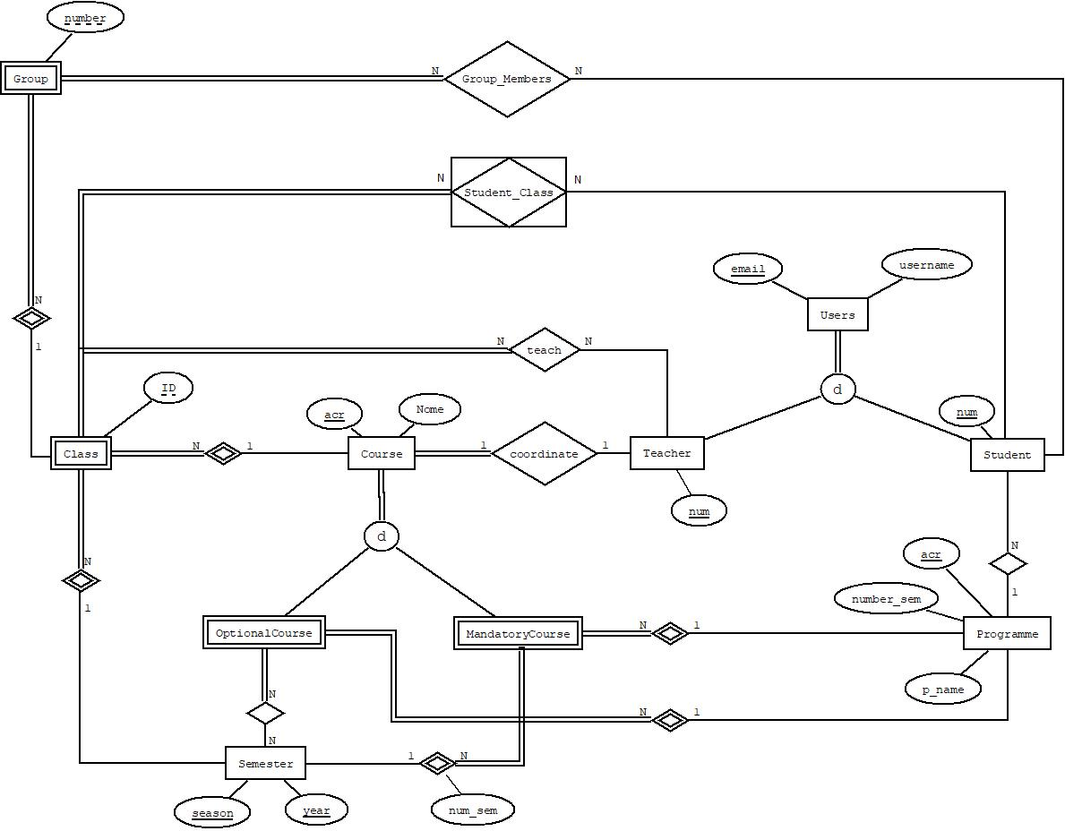

1. Modelo Relacional

|  |  |
| --- | --- |
| **Tabela** | **Chaves** |
| **Entidades Fortes** | |
| Users (email, username) | CC = {{email}} |
| Course (acr, c_name, numCoord) | CC = {{acr}}  CE = {{numCoord}}  numCoord: Teacher (num) |
| Programme (acr, p_name, number_sem) | CC = {{acr}} |
| Student (num, email, p_acr) | CC = {{num}}  CE = {{email}, p_acr}}  email: Users(email)  p_acr: Programme (p_acr) |
| Teacher (num, email) | CC = {{num}}  CE = {{email}}  email: Users (email) |
| Semester (season, year) | CC = {{season, year}} |
| **Entidades Fracas** | |
| Mandatory_course (acr, yearSem, season, acrProgramme) | CC = {{acr, year, season, acrProgramme}}  CE = {{acr}, {year, season}, {acrProgramme}}  year, season: Semester (year, season)  acr: Course (acr)  acrProgramme: Programme (acr) |
| Optional_course (acr, acrProgramme) | CE = {{acr}, {acrProgramme}}  acr: Course (acr)  acrProgramme: Programme (acr) |
| Class (id, year, season, acrCourse) | CC= {{id, year, season, acrCourse}}  CE= {{year, season}, {acrCourse}}  year, season: Semester (year, season)  acrCourse: Course (acr) |
| Group (number, classID, yearSem, season, acrCourse) | CC = {{number, classID, yearSem, season, acrCourse}}  CE = {{classID, yearSem, season, acrCourse}}  classID, yearSem, season, acrCourse:  Class (id, yearSem, season, acrCourse) |
| **Associações** | |
| Sem_Optionalcourse (acr, yearSem, season, acrProgramme) | CC = {{acr, yearSem, season, acrProgramme}}  CE = {{acr}, {yearSem,season}, {acrProgramme}}  acr: Optional_course (acr)  yearSem, season: Semester (yearSem, season)  acrProgramme: Programme (acr) |
| Teacher_Class (id, yearSem, season, numTeacher, acrCourse) | CC = {{id, yearSem, season, numTeacher, acrCourse}}  CE = {{id, yearSem, season, acrCourse}, {numTeacher}}  numTeacher: Teacher(num)  id, yearSem, season, acrCourse:  Class (id, yearSem, season, acrCourse) |
| Student_Class (numStudent, groupNum, idClass, yearSem, season, acrCourse) | CC = {{numStudent, idClass, yearSem, season, acrCourse}}  CE = {{numStudent}, {idClass, yearSem, season, acrCourse}, {groupNum}}  groupNum: Group (number)  numStudent: Student (num)  idClass, yearSem, season, acrCourse:  Class (id, yearSem, season, acrCourse) |
| Group_Members (number, studentNum, classID, yearSem, season, acrCourse) | CC = {{number, studentNum, classID, yearSem, season, acrCourse}}  CE = {{studentNum}, {number, classID, yearSem, season, acrCourse }}  studentNum: Student (num)  number, classID, yearSem, season, acrCourse:  Group (number, classID, yearSem, season, acrCourse) |